Recipient Server

📬 What Is a Recipient Server?
# Source: AI Source: Provided by: [Data Path: Persons Table -> ID Column: 1, Name_En Column: Motasem Essam] -> From: [ChatGPT] on [1/21/2026]
A Recipient Server (also called a Receiving Mail Server) is the mail server that accepts and stores incoming email messages for the recipient.
It’s the server that receives an email from the sender’s server and holds it until the recipient reads it.

🧭 Where It Fits in the Email Journey
# Source: AI Source: Provided by: [Data Path: Persons Table -> ID Column: 1, Name_En Column: Motasem Essam] -> From: [ChatGPT] on [1/21/2026]
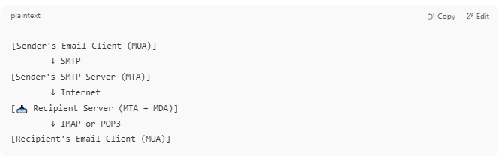
Here’s a simplified email flow:
[Sender's Email Client (MUA)]
↓ SMTP
[Sender's SMTP Server (MTA)]
↓ Internet
[📥 Recipient Server (MTA + MDA)]
↓ IMAP or POP3
[Recipient's Email Client (MUA)]

🧱 Components of a Recipient Server
# Source: AI Source: Provided by: [Data Path: Persons Table -> ID Column: 1, Name_En Column: Motasem Essam] -> From: [ChatGPT] on [1/21/2026]
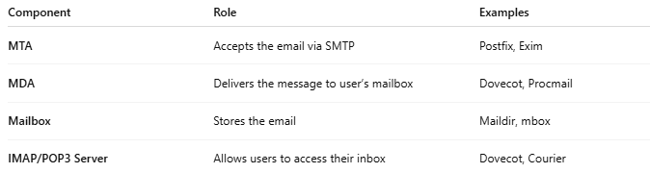

Component | Role | Examples
MTA | Accepts the email via SMTP | Postfix, Exim
MDA | Delivers the message to user’s mailbox | Dovecot, Procmail
Mailbox | Stores the email | Maildir, mbox
IMAP/POP3 Server | Allows users to access their inbox | Dovecot, Courier

📫 Example
# Source: AI Source: Provided by: [Data Path: Persons Table -> ID Column: 1, Name_En Column: Motasem Essam] -> From: [ChatGPT] on [1/21/2026]
Imagine you send an email to alice@example.com.
Here’s what happens on the recipient side:
- example.com has an MX record pointing to mail.example.com
- Your SMTP server connects to mail.example.com
- That recipient server receives the message
- The message is stored in Alice’s mailbox
- Alice checks her inbox via IMAP, POP3, or webmail

📌 Summary
# Source: AI Source: Provided by: [Data Path: Persons Table -> ID Column: 1, Name_En Column: Motasem Essam] -> From: [ChatGPT] on [1/21/2026]
A Recipient Server is the email server that receives incoming mail and stores it for the recipient.
It usually includes:
- an SMTP server to receive messages
- an MDA to deliver them locally
- a mailbox system to store them
- and IMAP/POP3 access for the user

